To Supply Leftover Food to Poor

## Project Overview

This project is focused on “To Supply Leftover Food to the Poor”, designed to address the challenge of food wastage and hunger. The goal is to deliver a comprehensive solution by leveraging Salesforce Nonprofit Cloud, Service Cloud, and Einstein Analytics. Through this project, we aim to enhance food redistribution efficiency, improve operational visibility, and foster community engagement, supporting the long-term goal of reducing food insecurity and minimizing food waste.

# Objectives

### Business Goals

* + Minimize food waste by redirecting leftover food to those in need.
  + Create a transparent and traceable food donation process.
  + Empower donors, NGOs, and volunteers with a seamless digital experience.

### Specific Outcomes

* + Development of a Salesforce-based platform to track and manage food donations.
  + Real-time inventory and logistics management for food pickups and deliveries.
  + Analytical dashboards to measure project impact and optimize operations.

# Salesforce Key Features and Concepts Utilized

**Salesforce Nonprofit Cloud**: For NGO collaboration and food request tracking.

**Service Cloud**: For handling donor and volunteer inquiries.

**Einstein Analytics**: To provide actionable insights through dashboards and reports.

### Custom Objects:

* + **Food Donations**: Tracks details of donated food.
  + **Pickup Schedules**: Manages logistics for pickups and deliveries.
  + **Distribution**: Logs food delivery to NGOs and end beneficiaries.

### Automations:

* + Email/SMS alerts for donation confirmations and task updates.
  + Workflow rules to assign volunteers for pickups.

# Detailed Steps to Solution Design

### Data Models

* + **Entities**:
    - Donor: Stores donor details.
    - Food Donation: Tracks donated food and quantity.
    - NGO: Manages charity details.
    - Volunteer: Manages tasks assigned to volunteers.
    - Distribution: Records food delivery status.

### User Interface Designs

* + **Donor Portal**: Simple and intuitive interface for logging food donations.
  + **Volunteer Dashboard**: A task overview page displaying pending and completed assignments.
  + **NGO Management Panel**: Interface for NGOs to view available food and request donations.

### Business Logic

* + **Triggers**: Apex triggers to automatically assign logistics resources to food donations.
  + **Validation Rules**: Ensures data integrity for donation entries (e.g., food expiry dates).
  + **Scheduled Jobs**: Automates the cleanup of expired food donation records.

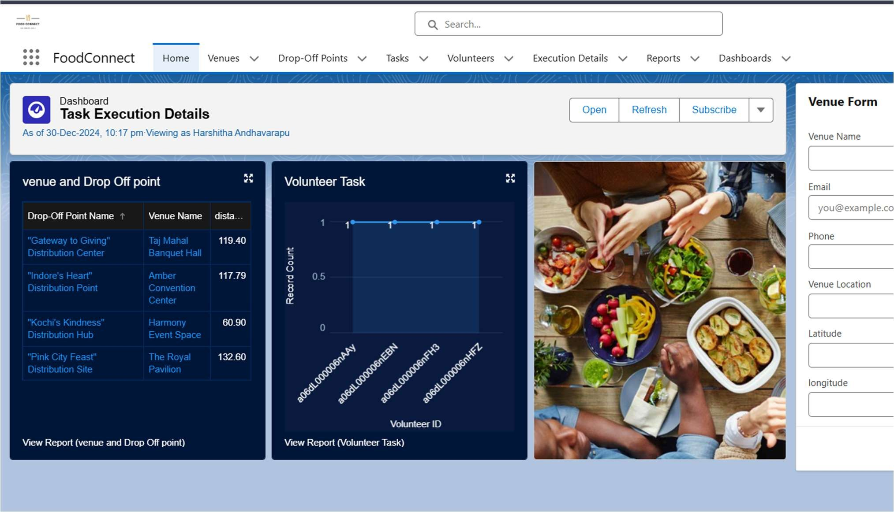

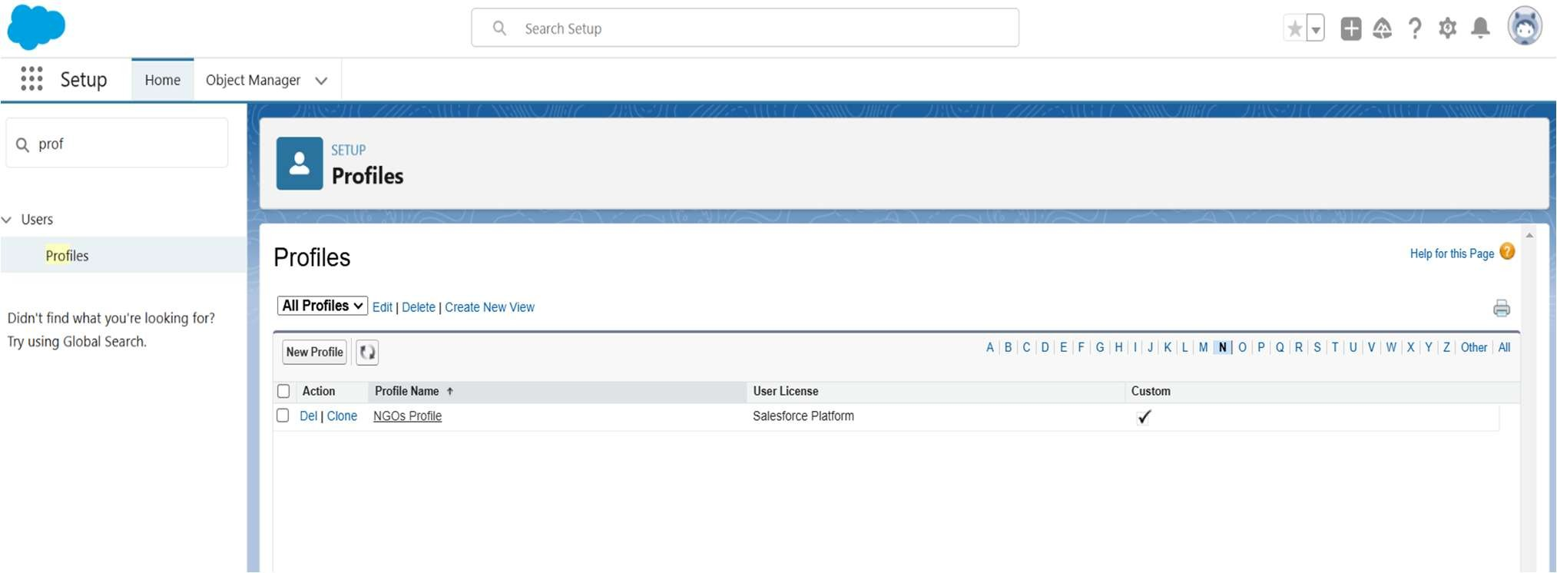

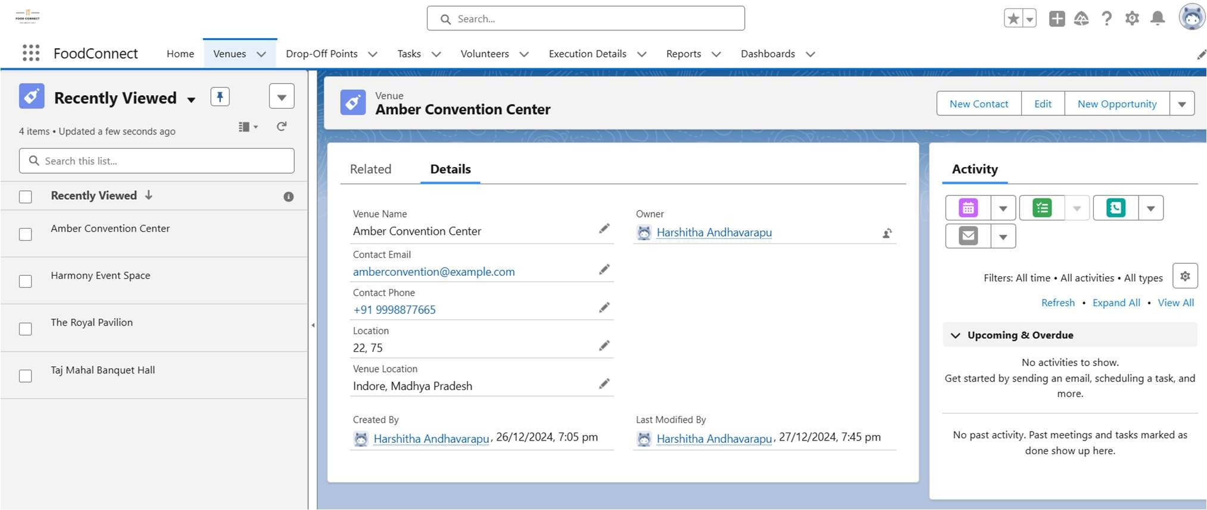

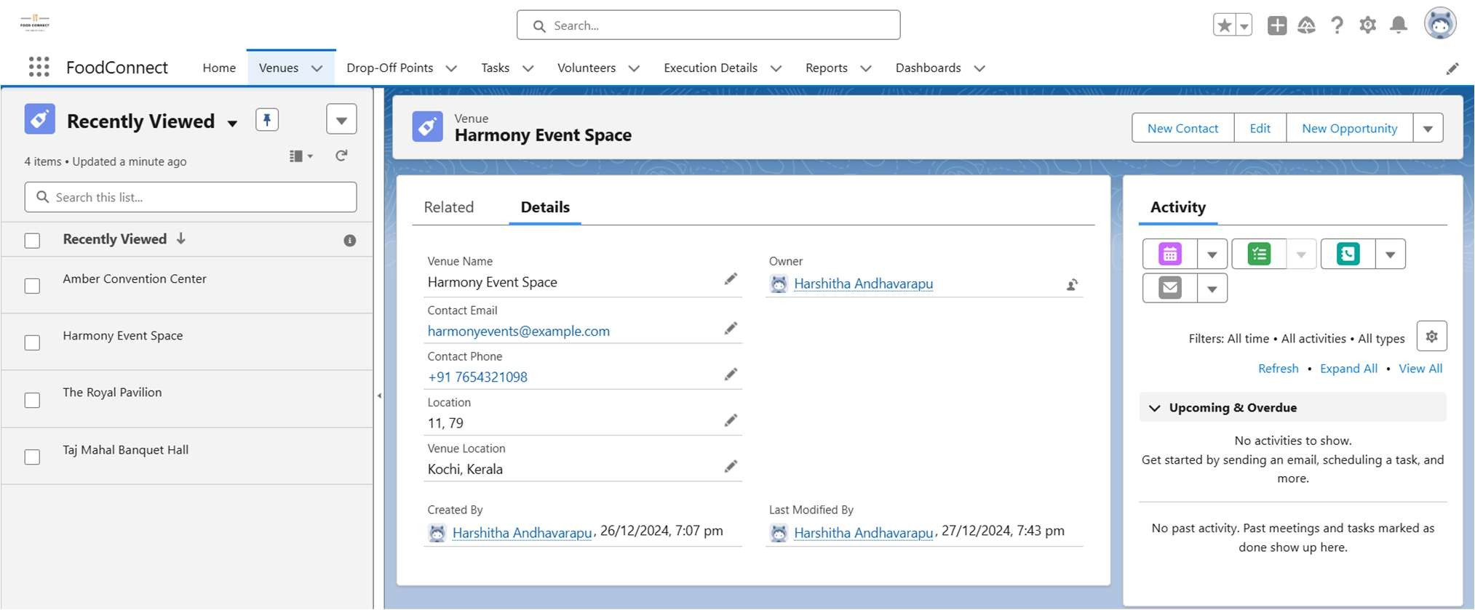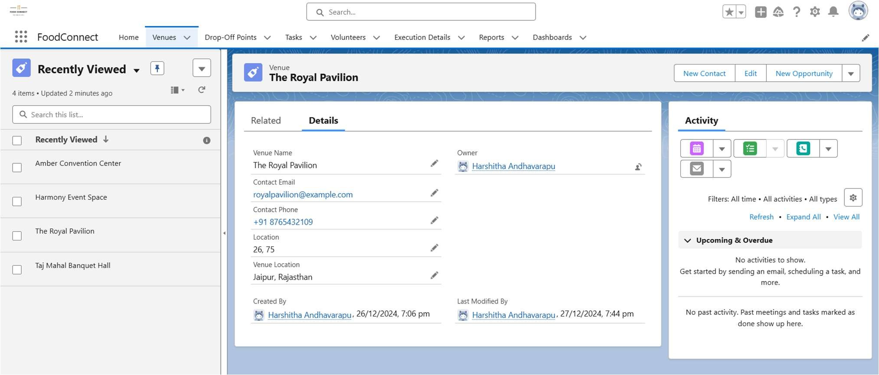

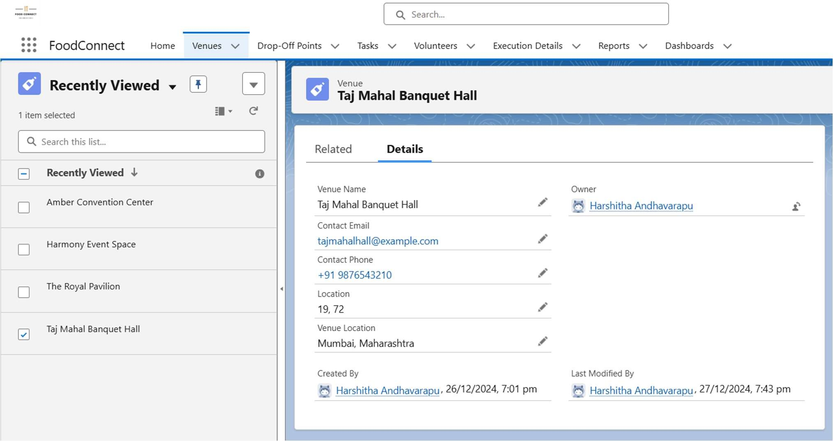

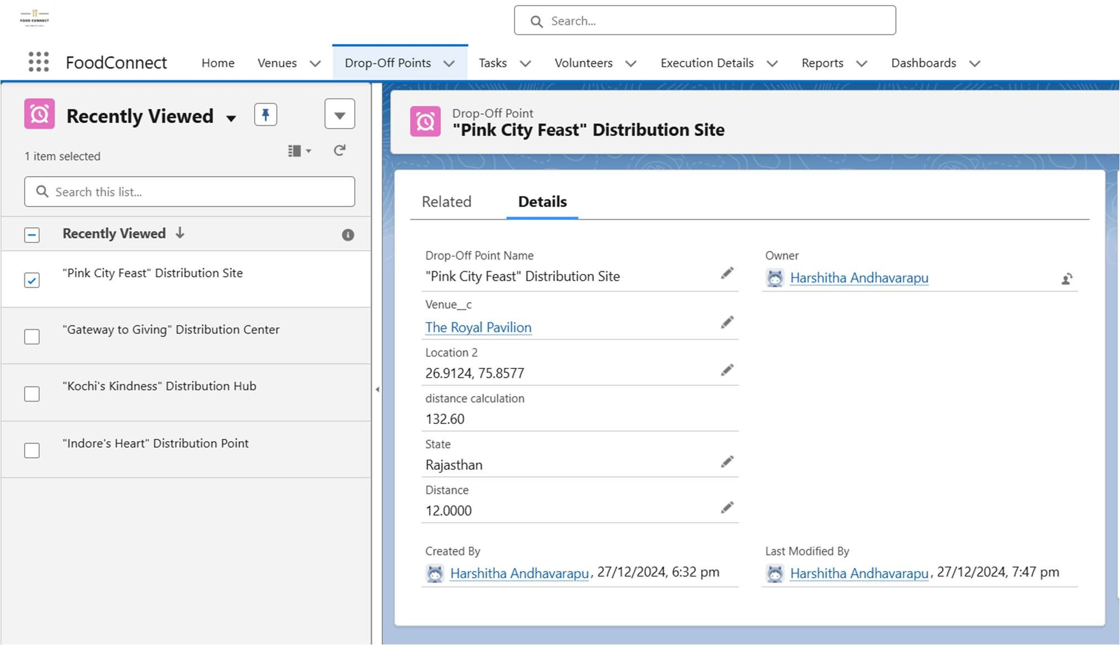

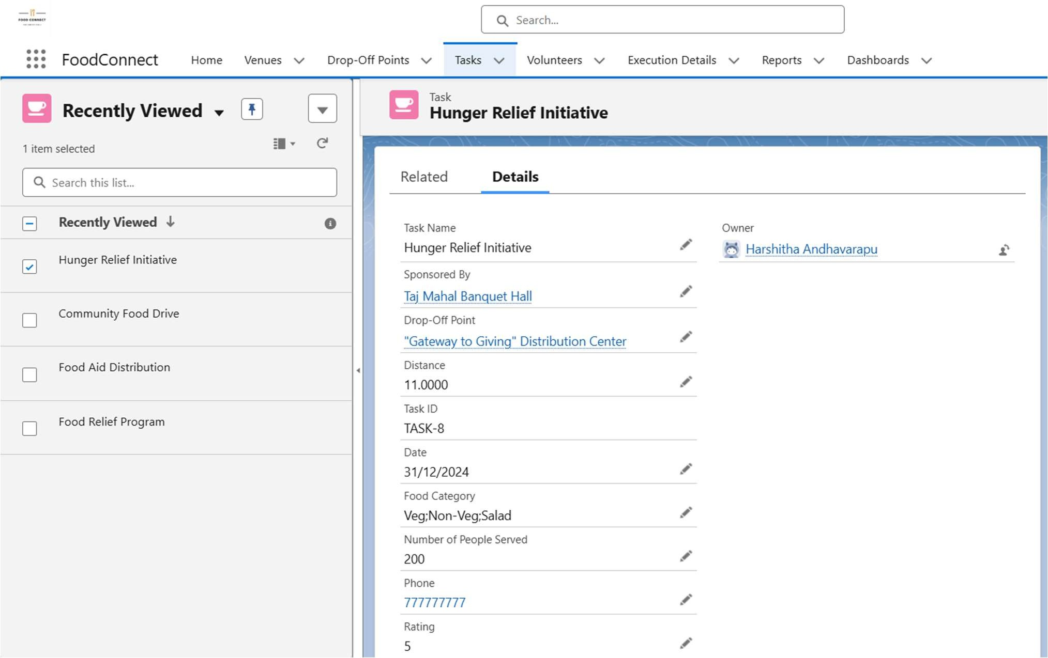

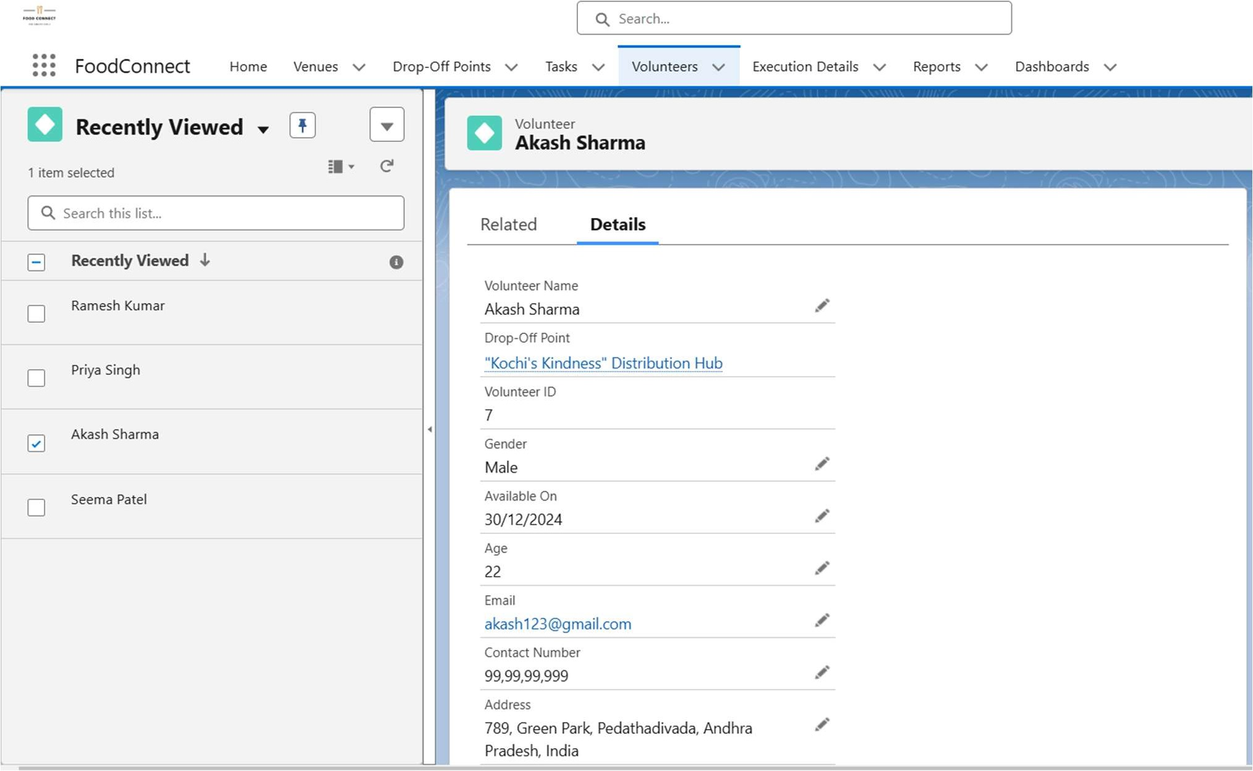

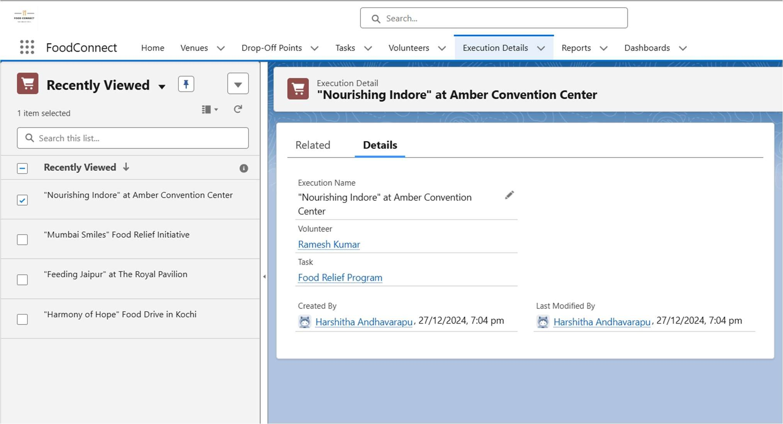

# Testing and Validation

### Unit Testing

* + Apex classes and triggers were tested with a minimum of 95% code coverage.
  + Validation rules and workflows were tested with dummy data to ensure correct behavior.

### User Interface Testing

* + Conducted end-to-end testing for donor, NGO, and volunteer portals.
  + Ensured mobile compatibility for on-the-go access.
  + Tested usability with stakeholders for a user-friendly experience. .

1. **Key Scenarios Addressed by Salesforce in the**

**Implementation Project**

This gives clarity that you are addressing various use cases or situations that Salesforce can handle during the implementation.

**Food Donation Management**: Donors can log leftover food details, and the system tracks food availability in real time.

**Pickup and Delivery Scheduling**: Volunteers receive automated assignments for pickups and deliveries.

**Transparency and Reporting**: NGOs receive detailed reports on food distribution, while donors can track their impact.

**Scalability**: The system supports multiple regions and can expand as the initiative grows. **Quality Assurance**: Alerts notify the system admin about food nearing expiration, ensuring timely distribution.

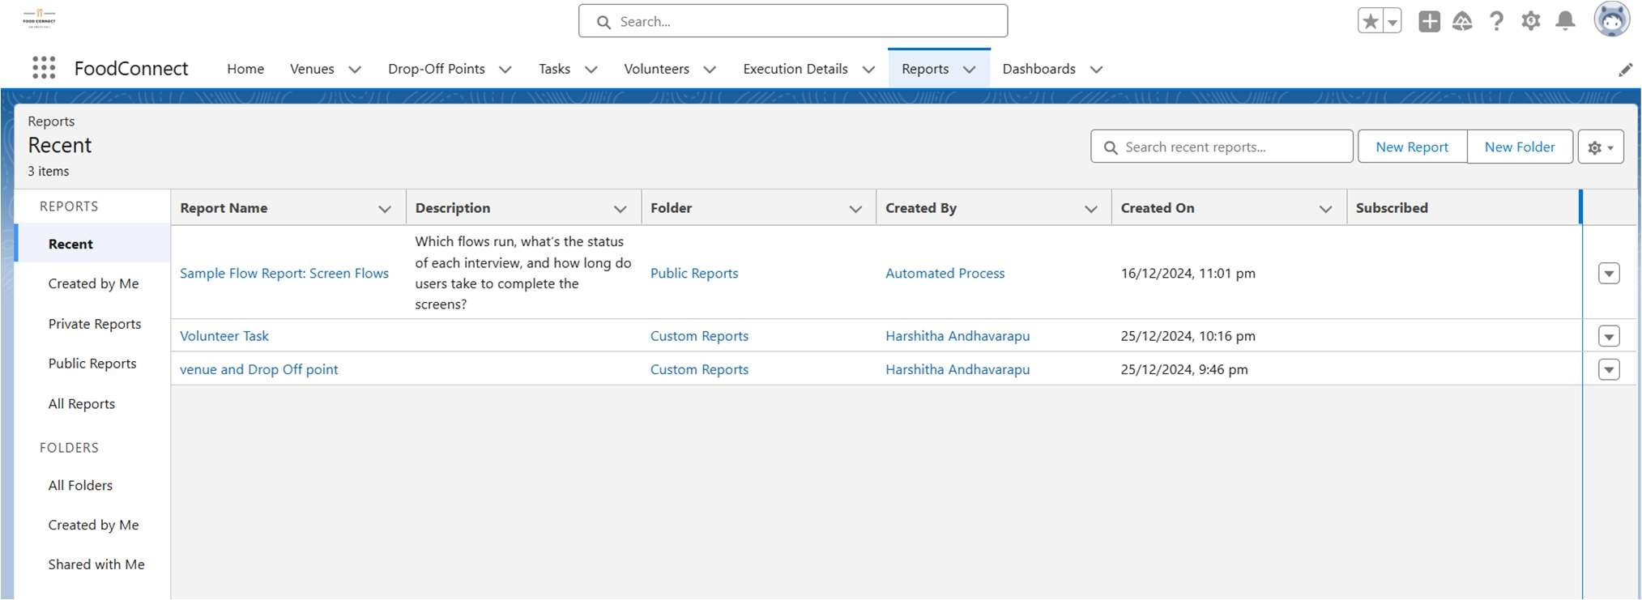

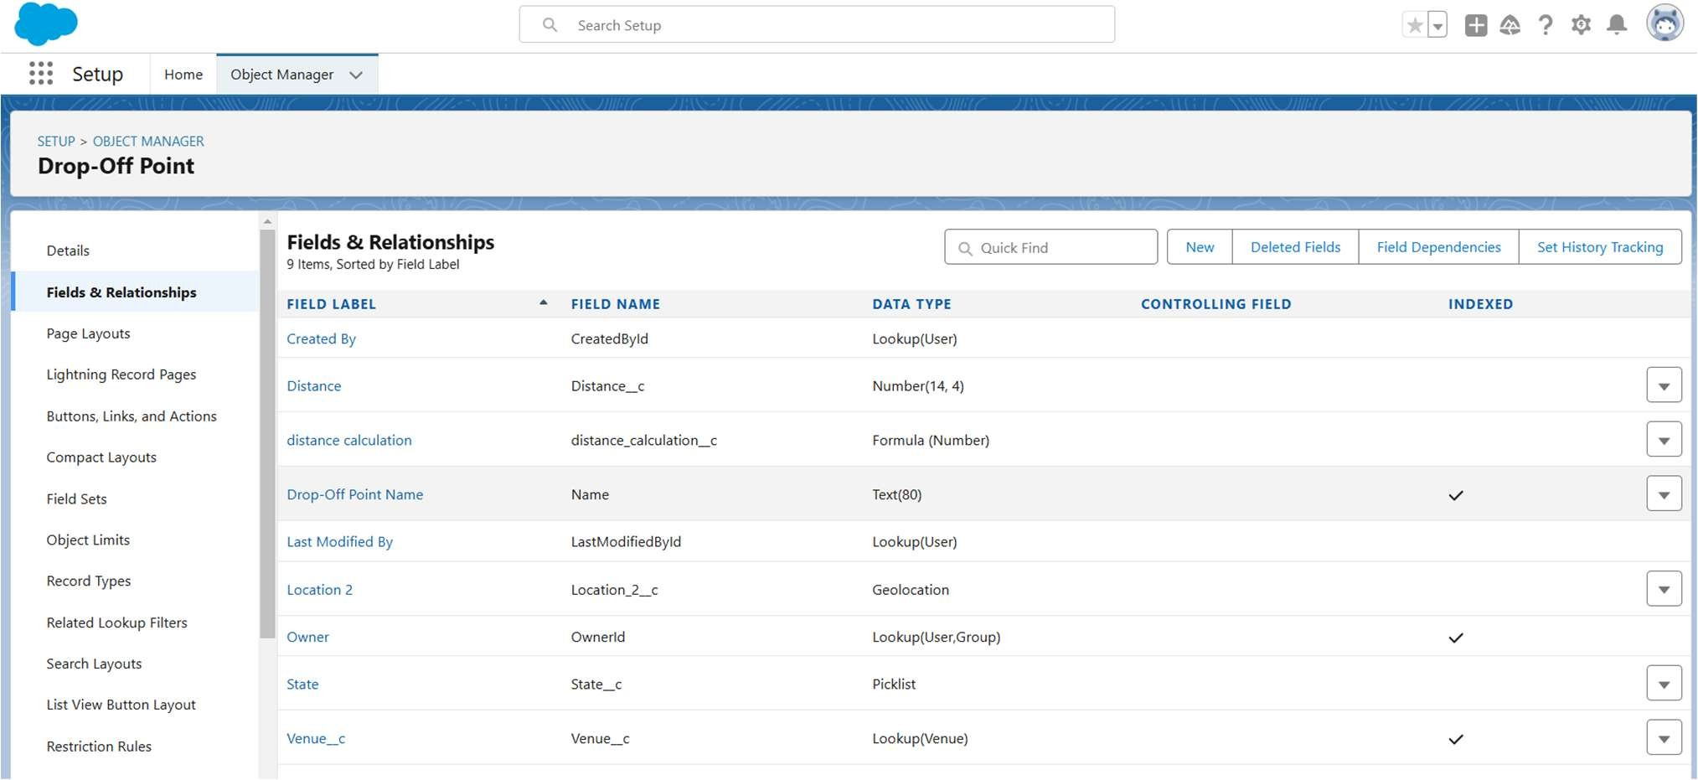

## Conclusion

The **“To Supply Leftover Food to the Poor”** project successfully addresses the dual challenge of food waste and hunger by implementing a Salesforce-based solution.

Achievements include:

* + Development of a transparent and efficient food redistribution platform.
  + Empowerment of stakeholders with real-time insights and streamlined workflows.
  + Significant reduction in food waste and meaningful contributions to communities in need.

This project demonstrates the power of technology in addressing social challenges and lays a foundation for future expansion and innovation.